Final Exam Project
1) Enter your name, student ID, platform and date
Name: Brian Quintero
Class: CIS054 C/C++ Programming
Platform (Mac or PC): Pc
Date: 5/25/17

2) PROJECT DESCRIPTION
Create an application that searches a file of male and female first names. A link to the file is provided on the class webpage. "FirstNames2015.txt" is a list of the most popular baby names in the United States and was provided by the Social Security Administration.
Each line in the file contains a boy's name and a girl's name. The file is space-delimited, meaning that the space character is used to separate the boy name from the girl name. The file begins with:
Noah Emma
Liam Olivia
Mason Sophia
Jacob Ava
William Isabella
Ethan Mia
James Abigail
Write a program that asks the user to enter a name. The program then searches the file for the name and displays the position of the name in the file if it matches either a boy name or a girl name. The program also displays a message if the name could not be found. Sample outputs:
Enter a name to search: Daniel
Daniel is ranked 12 for boy names
Daniel was not found for girls

Enter a name to search: Cassandra
Cassandra is ranked 511 for girl names
Cassandra was not found for boys

Enter a name to search: Taylor
Taylor is ranked 76 for girl names
Taylor is ranked 462 for boy names

NOTE: You can use any method you wish to match the name input on the keyboard with the names in the file. You can compare two strings ignoring upper/lower case by using #include<cstring> in C++ or #include<string.h> in C and the following comparison if ( stricmp(string1,string2) == 0)
If your compiler does not have stricmp, you may need to use _stricmp or strcasecmp.
3) DISCUSSION
a) What did you do to develop the program? ("Followed the Directions" is not a complete description
I had to set it up so if it read a girls name it would output girls name ranked, and vise versa for the boys.
After that I just had to set it up so the program pulled the file from my pc.

b) What problems did you have and how did you overcome the problems?
The hardest part was just setting it up for the girls vs the guys and setting it up so it read the rank.

4) PROGRAM OUTPUT
Submit seven screen shots:
1) search result for your first name
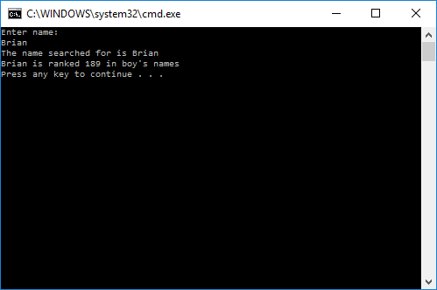
2) search result for a name used for both boys and girls, such as Taylor, or Dylan
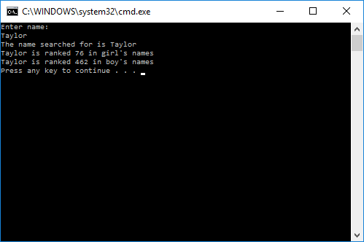
3) search result for a name used only for boys
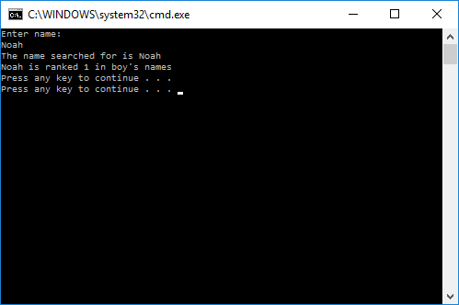
4) search result for a name used only for girls
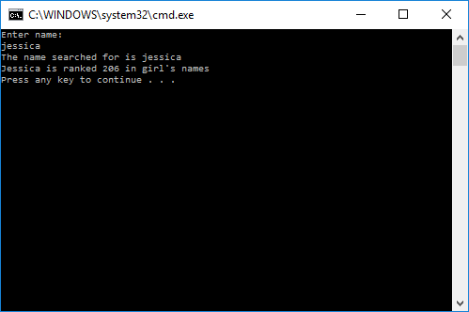
5) search result for a name that at the very top of the file
6) search result for a name that is at the very bottom of the file
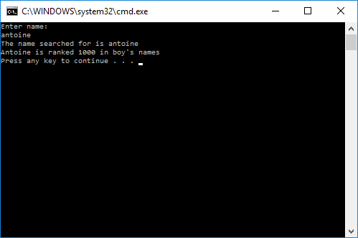
7) search result for a name that is not in the file
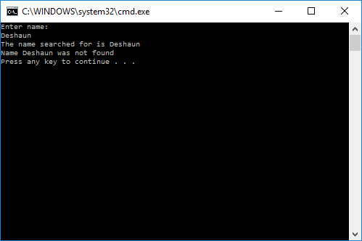
5) PROGRAM LISTING
Copy and paste YOUR code.
//Brian Quintero
//CIS-054 C/C++
//PC
//5/25/17

#include "stdafx.h"
#include <iostream>
#include <fstream>
#include <stdlib.h>

using namespace std;

int main(int argc, char* argv[])

{

char filename[] = "C:/Users/brianqp/Desktop/Final.txt";

char inputname[30];
char b_name[30];
char g_name[30];
int b_counter = 0;
int g_counter = 0;

ifstream infile(filename);

cout << "Enter name:" << endl;
cin >> inputname;
cout << "The name searched for is " << inputname << endl;

//Changing letter case

inputname[0] = toupper(inputname[0]);

for (int i = 1; inputname[i] != '\0'; i++)

inputname[i] = tolower(inputname[i]);

bool found = false;

while (!infile.eof())

{

infile >> b_name >> g_name;

bool g_found = strcmp(inputname, g_name) == 0;

bool b_found = strcmp(inputname, b_name) == 0;

if (g_found)

{

found = true;

cout << inputname << " is ranked " << g_counter + 1 << " in girls names " << endl;

}

if (b_found) //meaning found

{

found = true;

cout << inputname << " is ranked " << b_counter + 1 << " in boys names " << endl;

}

b_counter++;

g_counter++;

}

infile.close(); //close the file

if (!found) //meaning its false

{

cout << "Name " << inputname << " was not found " << endl;

}

system("Pause");

return 0;
}

